ART 2-D to 3-D Core Shadows and Core Shadows Name:____________________
Two-dimensional (2D)
- Having length and width
- Ex circle, square, rectangle, triangle, oval, trapezoid, etc
Three-dimensional (3-D)
- Having length, width and height
- Ex. Sphere, rectangular prism, cone, cylinder, triangular prism, etc
Core Shadows:
- Located on the object
- Always on side of object away from the light source
- 1/3 -14 of the way in from edge
- Found on spheres, cones and cylinders
Cast Shadows:
- Shadows created on another surface by the object.
- Example: tree casting shadow on the ground; an apple casting shadow on a table
Circle 2-D | Problems:  Flat spots  Bumpy spots  Pointy spots
SPHERE 3-D | SPHERE 3-D
TRIANGLE 2-D  Square/Rectangle 2-D  (X marks the spot) Axis of symmetry | CONE 3-D  Cylinder 3-D
Trapezoid 2-D  Horizon line Vanishing point  (Converging lines) | CANS of TUNA  HL

Rectangular prisms 3-D above HL and below HL

HL

Rectangular prism ON HL

HL

NOTE: Any paper/canvas is divided into three areas:

_____________________
_____________________
_____________________

PORTRAIT LANDSCAPE

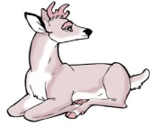
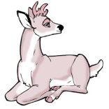

SWEET SPOTS 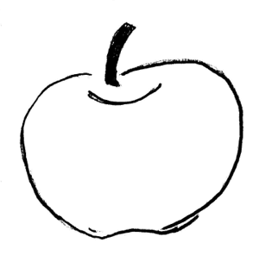

Remember:
In a piece of artwork,
- Use WHOLE objects
- Use PARTIAL objects
- NEVER, EVER place the EDGE of the object on the EDGE on the paper or canvas
Perspective:
Creating the illusion of a 3-D object on a 2-D surface
Three important things used to create perspective:
- Horizon line
- Vanishing point(s)
- Converging lines

