GRADE 8 MATH Unit 4: Measuring Prisms and Cylinders REVIEW Name:______________
NAME |  | DIAGRAM | NET
BASE:
SIDES:
FACE:
EDGES:
VERTICES:
BASE:
SIDES:
FACE:
EDGES:
VERTICES:
CUBE | BASE:  SIDES:  FACE:  EDGES:  VERTICES:
triangular  PYRAMID | BASE:  SIDES:  FACE:  EDGES:  VERTICES:
TRIANGULAR PRISM | BASE:  SIDES:  FACE:  EDGES:  VERTICES:
pentagonal PRISM | BASE:  SIDES:  FACE:  EDGES:  VERTICES:
Pentagonal pyramid | BASE:  SIDES:  FACE:  EDGES:  VERTICES:
Octagonal prism | BASE:  SIDES:  FACE:  EDGES:  VERTICES:
Octagonal pyramid | BASE:  SIDES:  FACE:  EDGES:  VERTICES:

2. Fill-in the blanks.
1. | 1. a prism with sides perpendicular to its bases
2. | 2. Where three or more edges meet
3. | 3. where two faces meet in a polyhedron
4. | 4. an object made from polygons
5. | 5. A prism with regular polygons as bases
6. | 6. Flat side of a prism
7. | 7. a 3-D object which has TWO parallel and congruent sides which are joined by  parallelograms as the other faces
8. | 8. Having length, width and height
9. | 9. a closed shape made from line segments
10. | 10. Having length and width

3. What is the difference between a right prism and a regular prism?_____________________________
_____________________________________________________________________________________
_____________________________________________________________________________________
_____________________________________________________________________________________

4. Complete the table.
Will this net  make a polyhedron? | ANSWER:  YES OR NO | REASON

5. A) How much cloth is needed to cover the surface of a triangular prism?

10.3 m 8m 15m
9 m

B) How much metal is needed to cover the surface of a triangular prism shaped shed?
(round to nearest tenth) 2.8mm
5 mm 3.7mm
13.1 mm
8.3 mm

6. A) What is the surface area of this right rectangular prism? 2.1 cm
(round to nearest cm²) 6.7 cm
7.4 cm

B) Given a cube with 1 face with area 22 m². What is the total surface area of the cube?

7. What is the surface area of this cylinder? 2 mm 6 mm
Both circles have the same radius.

- Find VOLUME.

- right rectangular prism 14.1 m

5.2 m

6.3 m

- Right triangular prism 15.4 mm

3.5 mm

12.4 mm

- Right cylinder 9.4 cm

18.7 cm

- Right cylinder 12 mm
6.3 mm

- A can of paint covers 25m² wall surface. If you paint your room twice and are in a room 6m x 4 m x 3 m, how many cans of paint do you need?

- You have an aquarium 60 cm x 80 cm x 70 cm. You fill it up with water 20 cm from the top. What volume of water is in the aquarium?

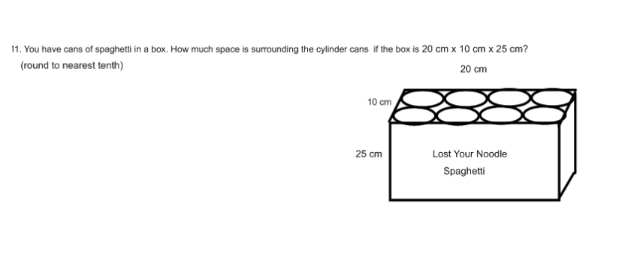
KEY: Unit 4: 3-D Geometry Midterm REVIEW SHEET
- rectangular prism b =2 rectangles s = 3 rectangles f= 6 e=12 v=8
cylinder b= 2 circles s-1 rectangle f=2 e=2 v=0
cube b= 2 squares s= 4 square f=g e=12 v=8
tetrahedron b= 1 triangle s=3 triangles f=4 e=6 v=4
triangular prism b=2 triangles s=3 rectangles f=5 e= 9 v=6
pentagonal prism b=1 pentagon s=5 rectangles f=7 e=15 v=10
pentagonal pyramid b=1 pentagon s=5 triangles f=6 e=10 v= 6
octagonal prism b= 2 octagons s=8 rectangles f= 10 e=24 v= 16
octagonal pyramid b= 1 octagon s=8 triangles f=9 e=16 v=9
2. 1. Right prism 2. Vertex 3 edge 4. Polyhedron 5. Regular prism 6. Face 7. Prism 8. 3-dimensional 9. Polygon 10. 2-dimensional
3. right prism ; sides perpendicular to bases regular prism: sides not perpendicular to base (slanted)
4. a) NO overlap and missing side b) yes bases opposite sides / 2 trapeziods and 4 rectangles for sides C) NO missing side
5. A) 516 m² b) 245.9 mm²
6. A) 158 cm² b) 132 m²
7. 100.48 mm²
8. A) 416.916 m³ B) 334.18 mm³ C) 1297.08062 cm³ D) 14955.192mm³

